Capstone Category Review

Encompassing the academic years 2002-2010

Approved by the Liberal Arts Core Committee (LACC) on October 20, 2011

Review by the Liberal Arts Core Committee, 2009-2011

Siobahn Morgan, LAC Coordinator
Maria Basom, University Faculty Senate
Jerry Smith, University Faculty Senate
Keith Crew, College of Social and Behavioral Sciences
Ana Kagl, College of Social & Behavioral Sciences
Betty DeBerg, College of Humanities & Fine Arts
Tony Gabriele, College of Education
Scott Giese, College of Natural Sciences
Stan Lyle, Rod Library
Jean Neibauer, Academic Advising
Philip Patton, Registrar
Jacob Rudy, Student Representative
Frank Thompson, College of Business Administration
Mike Klasses, College of Business Administration
Lori VanHooreweghe, Academic Learning Center
Donna Vinton, Office of Academic Assessment

Table of Contents

I. Executive Summary 3

II. Background and History 4

III. Category Goals 4

IV. Assessment 6
Results from the Student Surveys 6
Results from the Faculty Surveys 8
Direct Assessment Measurements10
Assessment Summary 10

V. Category Description and Course Syllabi Statements 11

VI. Statistical Data 12
Enrollment and Class Sizes 12
Grade Distribution 12
Staffing of Capstone 12
Statistics Summary 12

VII. Review of Syllabi 13

VIII. Recommendations………………………………………………...……………………...13

Appendices
Appendix A – Capstone Management Guidelines 14
Appendix B – Capstone Experience Courses – Fall 2002 – Spring 2010 18
Appendix C – Student Survey and Results 20
Appendix D – Faculty Survey and Results 22
Appendix E – Capstone Enrollments - Fall 2002 – Spring 2010 27
Appendix F – Capstone Staffing and Grades 30

I. Executive Summary

The review of the Capstone Experience category of UNI’s Liberal Arts Core echoes results from the Capstone reports which centered upon the inclusion of new courses into the category (The New Capstone Experience Model – Evaluation and Final Report, 2006). Among the most significant findings are the following –
- The new Capstone courses are viewed favorably by both students and faculty. The new courses have a higher level of positive feedback compared to the original version of Capstone, Environment, Technology and Society (ETS).
- The new Capstone courses tend to have a larger fraction of tenured/tenure-track instructors, smaller class sizes, and lower average GPAs compared to ETS.
- Study Abroad offerings in both ETS and the new Capstone courses have increased, particularly in the summer.
- The staffing of Capstone is now distributed across the university to more colleges and departments. Faculty are also able to expand their portfolio by developing new courses or providing their courses to a wider audience.

Several issues of concern are also worth noting. These pertain to the entire Capstone category and will need to be addressed by UNI faculty and administrators. These include the following –
- Not enough Capstone faculty had their students participate in MAPP testing.
- Syllabi for Capstone courses tend to lack information concerning the course learning outcomes/goals, the purpose of a Capstone course, and how it relates to a liberal arts education.
- The percentage of tenured/tenure-track faculty teaching ETS sections has fallen precipitously over the last two semesters. In spring 2010, only 29% of ETS sections were taught by regular full-time faculty.
- No opportunities for professional development of Capstone instructors have been available.
- No regular meetings of the Capstone faculty have been held.

Consequently, the LACC makes the following recommendations to the Provost, the Dean of CNS, and for its own work in the future:

- That the LACC develop a required syllabus template for the use of Capstone instructors. This template will include the official description of the Capstone Experience and its learning goals, specific learning goals for the course, and a day in the schedule devoted to required Liberal Arts Core student outcomes assessment. (The template would not limit the content of the syllabus, but simply provide required categories of information for each syllabus.)
- That failure to comply with the request for LAC student outcomes assessment may result in the removal of any Capstone course from the list of those approved by the LAC Committee.
- That the Dean of CNS increase the number of tenured/tenure-track faculty teaching ETS in order to reach the University’s strategic plan goal of 75% of courses being taught by tenured/tenure-track faculty. And, further, that the Dean and/or Provost provide professional development opportunities for instructors of ETS in order to address specific challenges of that course.
- That a Capstone Coordinating Committee by established in order to work with the LAC Coordinator to manage the category.

II. Background and History

Capstone has been a component of the Liberal Arts Core since 1988, when it was part of the Natural Science and Technology category of the then General Education program. All students were required to take two courses from the natural science category, initially in the “Spheres” and then in the “Life” and “Physical” science subcategories before taking Capstone. Originally, only one course was part of the Capstone experience, Environment, Technology and Society (ETS), and this course was offered predominantly by the College of Natural Sciences. In 2004 an experiment was initiated to expand the Capstone category by removing it from the Natural Science and Technology Category (currently Category 4) and placing it in its own Category (6). Also, the course requirements for Capstone were altered to allow courses with other topics to fulfill the Capstone category requirement. From fall 2004 through spring 2007, courses from all colleges were developed or redesigned to meet the Capstone model. In spring 2007, the Faculty Senate approved the new model for Capstone (see section III) and in spring 2008 approved the Capstone management guidelines (included in Appendix A).

Currently there are more than 35 different Capstone Experience courses available to students, including some that involve travel abroad or service learning opportunities. A list of all courses that have been approved as Capstone Experience courses since the last review (2002) is in Appendix B. The majority of these courses are also part of the UNI curriculum, having either been previously offered at UNI or added via the standard curriculum approval process.

III. Category Goals

The original goals for the Capstone category were developed in 1986 and applied to a single course, Environment, Technology and Society (ETS). These goals include the following –

1) facilitate a synthesis of the student's educational experience of the first three years;

2) emphasize the complexity and connectedness of the natural and social components of our environment;

3) develop an appreciation of the value of all academic disciplines in intelligent and informed decisions in our changing world;

4) demonstrate that learning should not end at graduation but be a life-long process.

The Capstone model remained the same until the experiment to expand it was started in 2004. As part of the revised model for Capstone proposed by the Liberal Arts Core Committee (LACC), the course was moved into its own category (6), and the following description was provided for the category and its goals -

The LACC proposes that an integrative Liberal Arts Core experience is highly desirable during the junior or senior year as an aid in preparing UNI students for the complex world of ideas that should engage them during their lives as educated citizens. The LACC also understands that any Capstone experience must be sufficiently flexible in content to allow and encourage widespread participation by UNI faculty.
With this goal and this condition in mind, the LACC recommends that the Liberal Arts Core Capstone two-credit requirement be revised to provide each UNI undergraduate with a course selected from a list of courses approved by the LACC.

This course
- Will have enrollment limited to juniors and seniors;
- Will be attractive and accessible to students from a wide spectrum of disciplinary backgrounds;
- Will, at a minimum, either 1) integrate content from two or more diverse disciplines, or 2) emphasize service-based learning and provide engagement with communities outside UNI.

In identifying Capstone courses, the LACC will be guided by the following desirable course attributes.
That the course
- Be intellectually challenging and promote development of higher-order thinking skills;
- Make student disciplinary diversity a strength of its design;
- Link theory to practice through applied problem-solving activities;
- Promote the development of skills and dispositions associated with self-directed, life-long learning.

The LACC uses these guidelines in the evaluation of course proposals for the Capstone Experience Category. These goals are also provided on the LAC website (www.uni.edu/vpaa/lac), and potential course proposers are directed to this information early in the process of developing a course or determining if a current UNI course would be appropriate for Capstone.

The Capstone Experience is designed as a final course of the Liberal Arts Core, and should make use of previous LAC student experiences. In this respect, it is expected to provide a measure of student learning in other areas of the LAC, particularly in how well students bring their diverse backgrounds to the course. Unlike the original model for Capstone which relied heavily upon courses from a single area of the LAC, courses in the current model can make use of various skills and knowledge obtained in all areas of the LAC. The multi-disciplinary and sometimes experiential nature of Capstone makes it an appropriate course for the LAC.

IV. Assessment

The course goals described above are incorporated into the assessment of the Capstone Experience category, which includes a student perception survey and a faculty survey. The surveys were administered during the 2004-2007 test run of the experimental model for Capstone and also in fall 2008 and fall 2009. The student survey and its results are provided in Appendix C, while the faculty survey and results are in Appendix D. Documents containing all student comments from these surveys are also available at a secure website available to faculty through the LAC website (www.uni.edu/vpaa/lac/secure/). These student comments have been edited to remove information that would identify instructors or specific courses, which are often taught by only one instructor.

Results from the Student Survey

This survey was developed and initially used during the experimental phase for the new Capstone model; it was administered in paper form in 2005 and 2006. An electronic version was used in 2008 and 2009, and only slight variations have been made to the instrument during the past 5 years. The survey uses the standard Likert scale and provides a space for comments. The survey presented in Appendix C is from the on-line 2009 version. Among the differences of the survey instruments are the following:
Question 1 was added to the on-line version; previously sections were hand sorted.
Question 2 was added in 2009.
Question 3 uses the following scale: 1=Strongly disagree, 2=disagree, 3=neither agree nor disagree, 4=Agree, 5=Strongly Agree
Responses from the comment section are available from the secure LAC document website.

The student survey was distributed in 2005, 2006, 2008 and 2009 for students in both versions of Capstone, ETS and the new courses. The results, including average scores for the questions for each year, are shown in Appendix C. The 2009 survey included students who took Capstone courses during the summer of 2009.

For the following statements from question 3 of the survey, students in the new Capstone courses indicated a higher level of agreement than students in sections of ETS –

A. Topics and discussion in this Capstone course integrated content from two or more diverse disciplines.
B. This Capstone course would be interesting to students from a number of majors.
C. Having students with various majors enhanced discussion and other activities in this Capstone course.
D. This Capstone course was intellectually challenging.
E. This Capstone course required me to use critical thinking skills.
I. One goal of a Capstone course is to connect students to the complex world of issues and ideas they will encounter after graduation. Measured against this objective, this Capstone class was successful.

Typically the values from the new Capstone sections were above 4 (“Agree”), while those from ETS sections were less than 4, in some cases significantly less.

There was general agreement on these questions between the two groups -

F. This Capstone course offered opportunities to write and/or make presentations.
G. This Capstone course offered opportunities for active involvement through in-class activities and/or small-group discussions.
H. I felt adequately prepared for this Capstone course’s activities and expectations.

The scores for these showed stronger agreement with the question about writing and less agreement with the preparation.

Student comments about Capstone cover a wide range of responses, and they are different based upon which version of Capstone the student had taken. Comments can be classified in several ways –
A. Positive view of course – such comments were often specifically related to the quality of the instructor, the format of the course, and how the course enhanced the student’s education.

B. Negative view of the course or the Capstone requirement – like the above, these were often linked with the instructor, with complaints of the quality of instruction, the treatment of students, the fairness of grading, etc. The most common statement about the Capstone requirement in general was “waste of time”, which appears often.

C. Question the course content – students often negatively reacted to the course description or title, or viewed the content as being too narrow. Some thought ETS was not entirely balanced between the three subjects in the course title, or that new Capstone courses had narrowly defined topics, or topics that were not clearly described in the course title or description.

D. Course was too much work/too difficult – while this could be part of the general negative views of the courses, this complaint often was brought up when the number of credits earned did not match the amount of work expected. For some of the new Capstone courses there were complaints that students may not be adequately prepared for the course work, particularly if the topic was considered too specialized or narrow.

The student comments obtained in the 2005, 2006, 2008 and 2009 surveys were examined for both versions of Capstone, and some very striking differences were noted. More students had negative comments concerning ETS (134 “B” comments versus 100 “A” ones). For the new Capstone courses this trend was dramatically reversed, with almost 3 times more positive comments about the course versus negative comments (185 versus 63). The overall positive perception of the new Capstone courses was clearly seen with comments that were also reflective of the students’ abilities and skills (course instructor and topic deleted for confidentiality) –

(Dr. X’s) class is the best class that I have ever taken at UNI. The class was challenging and required hard work and close reading, something that all upperclassmen should be required (and well able) to do before graduation, especially in a class not related to their majors. The class offered a variety of exposures to artistic expressions of the (topic X) and certainly improved my knowledge of and interest in (topic X). This is unquestionably largely connected to Dr. X's selection of literature and films for the class, and her passion for and knowledge of (topic X). Great class, great Capstone. I am very grateful for having taken a tough class-- I learned A LOT.

(Course X) was very interesting, I used the information we learned in class in other classes, it was challenging but rewarding.

This class was very interesting and something I wouldn’t have taken for my major. I hope you keep this class – it really opened my eyes, and I feel much more in-tune with the world around me after taking it.

Similar world-view-changing comments were also seen in ETS comments, such as

This class has caused me to re-evaluate many life choices. It helped me to think critically and make more environmentally safe choices.

The teacher was very good. Class was challenging in the way it makes you think about your everyday lives and the choices we make. I really liked having field trips to an actual power plant and water treatment plant. I would definitely recommend this class and instructor.

Based upon the analysis of comments, one of the strongest indicators of student engagement and appreciation of the Capstone Experience course lies with the instructor. The quality of instruction would appear to be the strongest influence on a student’s experience and would often be the first criticism or praise for a course. It is also clear that the new course options for Capstone are welcomed by the students and remain popular.

Results from the Faculty Survey.

In 2005, 2006, and 2010 questions about the student populations in Capstone courses and teaching Capstone courses were asked of faculty in both the new Capstone Experience courses as well as ETS. The results of the individual surveys are shown in Appendix D. The 2010 survey included additional questions concerning course delivery, assessment methods, writing assignments, and attendance grading. Comments from the faculty surveys are included at the secure website accessible from the LAC website.

Faculty perceptions of student background, preparation and course attitudes are very similar for both ETS and new Capstone instructors. The standard 5-point Likert scale for these questions indicate that, for both groups of faculty, the lowest value in the survey concerns student preparation for the course. High scores are in nearly all of the other survey questions indicating faculty satisfaction with diverse student backgrounds, student opportunities in classes, and interest in teaching Capstone again.

For the 2010 survey faculty were also asked questions concerning the methods of instruction and assessment methods used in their class. ETS instructors used several methods, most frequently including small and large group discussions, team projects, and movies/media. The commonly used instructional methods for new Capstone courses included small and large group discussions, lecture, and student presentations. It is interesting to note that more of the new Capstone instructors responded that they use “lecture”, “small group discussions” and “games and simulations” than ETS instructors, while more ETS instructors made use of “case studies” than the new Capstone instructors.

Assessment methods for the two formats of Capstone were also varied. Both new and ETS Capstone instructors rely mainly on student participation in class discussion as their main assessment method, and reflective papers/essays were also very frequently mentioned for assessment. New Capstone instructors more often use assessment methods such as “research reports/papers”, and “exams”, while ETS instructors are more likely to use “creative projects/presentations” and “short quizzes” for student assessment. The 2010 survey also included a question about paper length, and shorter papers (2 pages or less and 2-5 pages) are more common in ETS classes, while new Capstone courses use slightly longer length assignments (2-5, and 5-10 page papers). Both groups also commonly factor attendance into student grades, either as part of the grade or as a factor that can influence a grade.

Another important issue associated with Capstone courses is support for instructors in both the development and the delivery of their courses. New Capstone instructors sited “encouragement from Department Head” and “conversations with colleagues outside of my department” as factors that helped in course development, while ETS instructors sited “Previous experience with multidisciplinary courses” as their main factor. The question concerning factors that would be useful for faculty in general to develop and teach Capstone courses included for both groups “Opportunities to interact with colleagues who have offered Capstone courses” and “Information on models of other Capstone courses”. New instructors also noted that “Encouragement from Department Heads and/or Deans” were an important factor, while ETS instructors also frequently cited “Workshops on topics related to Capstone course development”.

Faculty comments concerning Capstone are also varied. The most frequent comment from ETS instructors concerns the need for including the content of ETS into the curriculum and not making it optional for UNI students. The most frequent comment from new Capstone instructors pertains to the enjoyment of teaching a Capstone course. Both groups of faculty did note frustration in student preparation for the course, lack of support from administration for development of courses, the use of the course to “punish” faculty, the need for more discussion among faculty about teaching this course, and the call for standardization of course models (rigor, assessment methods of students, grade inflation, etc).

Direct Assessment Measures

The Faculty Senate approved the management guidelines for the Capstone Experience course in the spring of 2008, and these are included in Appendix A. An important component in these guidelines is the use of Capstone sections for MAPP (Measure of Academic Proficiency and Progress) testing due to the large numbers of seniors and the diverse range of majors in most sections. Specifically, the following guidelines were approved: “Capstone instructors are required to make one session of their course available to outcomes assessment each semester. Instructors are encouraged to provide incentives – for instance, class participation points – for students who participate in outcomes assessment activities”.

In spite of repeated prompts from the Director of Academic Assessment and the LAC Coordinator, many Capstone instructors with a large number of seniors do not include MAPP testing in their course requirements. If included, it may be only provided as an optional activity for students or an activity that lacks any incentive for student participation. As a result, the data from MAPP testing of seniors is unreliable. This has a greater impact on UNI apart from general assessment of student learning. MAPP testing is one of three instruments approved by the Voluntary System of Accountability for measuring student learning outcomes. In spring 2007, only 123 seniors were involved in MAPP testing, while in spring 2008, only 57 seniors took part in the testing. The low number of students tested in 2008 prevented the Office of Academic Assessment from drawing any meaningful conclusions of student learning outcomes for seniors that year.

For further information concerning MAPP testing results, please examine the data available at the Academic Assessment website - https://www.uni.edu/assessment/.

Assessment Summary

Several important conclusions can be drawn from the various indirect and direct assessment methods.
- Students overwhelmingly view the new Capstone experiences courses more favorably than the ETS course, particularly by having the opportunity to select a course with a topic of their own choosing.
- Students do feel that they are challenged by Capstone and indicated that they used critical thinking skills and found class diversity to be an asset.
- Students still question the need for a Capstone course, or the need for LAC distribution requirements; however, a greater number of students do find the experience to be positive or of benefit to their academic career.
- Faculty views varied, but often positive experiences were noted in teaching the course, particularly among those teaching the new Capstone courses.
- Suggestions from faculty for greater oversight of course rigor, requirements, grading, and structure were often suggested in the surveys, as well as the need for faculty development opportunities.
- Participation in MAPP testing is grossly lacking, and this results in a negative impact on our reporting of student learning outcomes.
Student and faculty comments make several valuable suggestions that can be implemented in improving Capstone courses, and all instructors and administrators are encouraged to examine these comments located at the LAC secure website.

V. Category Description and Course Syllabi Statements

The current description of the Capstone Experience Category is given on the LAC website. The current statement for syllabi is comprised of the second paragraph of the description for the category. The category description is provided here –

The Capstone Experience is a university-wide endeavor organized as a distinct part of the Liberal Arts Core and designed as an aid in preparing UNI students for the complex world of ideas that should engage them during their lives as educated citizens. Therefore, all Capstone courses should be intellectually challenging and promote development of higher-order thinking skills; make student disciplinary diversity a strength of its design; link theory to practice through applied problem-solving activities; and promote the development of skills and dispositions associated with self-directed, life-long learning.

Capstone courses provide opportunities for students to synthesize the diverse realms of thought they have studied and to apply the intellectual proficiencies they have acquired. The emphasis is on cultivating life-long learning through linking theory and academic preparation to practical problem-solving activities in multidisciplinary seminars or community-based learning courses.

The description and statement for syllabi should be revised to reflect the expanded course offerings which have a wider range of student experiences as well as the use of Capstone courses for student learning assessment (currently through MAPP). The following are the recommended changes for the category description, and the statement for syllabi (changes in italics) -

The Capstone Experience is a university-wide endeavor organized as a distinct part of the Liberal Arts Core and designed as an aid in preparing UNI students for the complex world of ideas that should engage them during their lives as educated citizens. Therefore, all Capstone courses should be intellectually challenging and promote development of higher-order thinking skills; make student disciplinary diversity a strength of its design; link theory to practice through applied problem-solving activities; and promote the development of skills and dispositions associated with self-directed, life-long learning.

Capstone courses provide opportunities for students to synthesize the diverse realms of thought they have studied and to apply the intellectual proficiencies they have acquired. The emphasis is on cultivating life-long learning through linking theory and academic preparation to practical problem-solving activities in multidisciplinary courses, international travel opportunities, or community-based learning courses. These courses provide an important opportunity for assessment of student learning in the senior year.

It is recommended that the above changes to the statement be added to the LAC website upon approval of this report by the LAC Committee and the Faculty Senate.

VI. Statistical Data

A variety of data for all Capstone sections is available at the Office of Institutional Research website and is included here in an alternate format in Appendices E and F. Important aspects of these data sets will be described below.

Enrollment and Class Sizes

Currently approximately 1000 students register for Capstone each fall and spring semester, while the enrollment during the summer has increased from about 400 to 500 students. The number of students enrolled in the new Capstone courses has increased to nearly 400 during the fall and spring semesters, while the summer semesters have shown steady enrollment growth in the new offerings. During the past two summers, slightly more students have taken the new Capstone courses than the traditional ETS offerings.

Another factor that has had an impact on enrollments is the number of Study Abroad courses that are included in the Capstone models, both for ETS and new Capstone offerings. These offerings make up a significant fraction of the new Capstone courses in the summer, but ETS offerings abroad have also increased in recent years.

Class size data is also provided in Appendix E. It is readily apparent that the expansion of the Capstone model has resulted in a decrease in class sizes in all sections of Capstone, including ETS sections. Currently ETS sections average approximately 32 students, while the new Capstone sections have an average class size of 23 students. Prior to the introduction of the new Capstone courses, ETS courses averaged approximately 36 students per section.

Grade Distribution

Data concerning grade distribution in Capstone courses is provided in Appendix F. The overall average grade for Capstone has dropped since the introduction of the new courses, but it is not wholly the inclusion of those courses that has resulted in the drop of the average GPA. With fewer ETS sections by adjuncts offered, ETS GPA went up because adjunct ETS instructors give higher grades on average than do tenured/tenure-track ETS instructors. It also should be noted that summer Capstone course grades tend to be higher on average, and this may be the result of several factors including the student population, instructors, or increased Study Abroad offerings. Apart from summer offerings, the average grades in ETS sections are currently 0.2 grade points above those in the new Capstone sections.

Staffing of Capstone

Nearly all of the new Capstone courses are offered with tenured or tenure-track instructors, while the percentage of instructors in ETS sections generally hovers around 50%. The vast majority of the new Capstone courses are delivered by tenured or tenure-track instructors, while typically less than ½ of the sections of ETS are delivered by tenured or tenure-track instructors. This trend also existed before the introduction of the new Capstone offerings.

The distribution of Capstone instructors across the colleges is indicated as well in graphical form. In general ETS is dominated by CNS adjuncts, while the majority of new Capstone courses have come from CHFA and CSBS. It is worth noting that all of the colleges at UNI have either developed new Capstones or re-structured currently existing courses to be included in this Category. This makes the Capstone category unique amongst all of the LAC through the participation of all colleges in its offerings.

Statistics Summary

Several noteworthy trends are seen in the statistical data for the Capstone courses over the past 8 years, particularly once the new Capstone courses were introduced.
- While the number of students in the new Capstone courses has increased since 2004, there are still more students enrolled in ETS, with those sections offered predominantly by adjunct faculty in CNS, while the number of sections of new Capstone are provided by tenured or tenure-track faculty in CHFA and CSBS.
- The resulting change in Capstone has led to an overall drop in the average GPA of all Capstone courses, while the new Capstone courses still have the lowest average GPA.
- The average class sizes for all sections of Capstone have decreased, though ETS sections still average more than 32 students per section.

The data indicate favorable changes, including the decrease in class sizes, the use of fewer adjuncts and responsibility of Capstone distributed to more areas of the university.

VI. Review of Syllabi

Syllabi from nearly 40 Capstone courses were examined for the following attributes –
- Basic course information, including methods of contacting the instructor, office hours, course meeting times, locations, titles, section numbers, etc.
- Course description
- LAC information, including how Capstone fits into the LAC program
- Learning goals for the course or Capstone
- Grading criteria, students assessment methods
- Course schedule, including readings, assignment deadlines, exam schedule
- Late work/exam make-up policy
- Plagiarism policy/information
- Student disability services accommodation statement (such as those available at http://www.uni.edu/sds/SyllabusStatementSamples.shtml, Office of Disability Services).
- Discrimination and harassment policy (http://www.uni.edu/policies/1302)

The sample included 14 syllabi from ETS instructors, and the remaining were from the new Capstone courses, including several that involved travel in a foreign country.

The majority of syllabi included basic curricular information, such as course and instructor information, but most (~75%) did not describe the LAC, use the syllabi statement for Capstone courses, or describe how the course met the LAC Capstone criteria. Only about 2/3 of the syllabi described the learning goals for the course.

University policies, including a student disability services statement, plagiarism policy, or non-discrimination policies were observed in several syllabi, but were not consistently used. Most syllabi did not mention or describe the consequences of plagiarism, and only two courses include a non-discrimination policy (these courses were actually from the same academic unit). About 2/3 of the syllabi included a student disability services statement.

While it is possible that Capstone faculty explain to their students the importance of the course during the semester and how it relates to the rest of the LAC, it is recommended that explicit statements concerning the Capstone Experience be included in all of these syllabi. Instructors are encouraged to use the language provided in section V above, or similar information, addressing how the course topic fulfills the criteria for being a Capstone Experience course.

VIII. Recommendations

1. That the LACC develop a required syllabus template for the use of Capstone instructors. This template will include the official description of the Capstone Experience and its learning goals, specific learning goals for the course, and a day in the schedule devoted to required Liberal Arts Core student outcomes assessment. (The template would not limit the content of the syllabus, but simply provide required categories of information for each syllabus.)

2. That failure to comply with the request for LAC student outcomes assessment may result in the removal of any Capstone course from the list of those approved by the LAC Committee.

3. That the Dean of CNS increase the number of tenured/tenure-track faculty teaching ETS in order to reach the University’s strategic plan goal of 75% of courses being taught by tenured/tenure-track faculty. And, further, that the Dean and/or Provost provide professional development opportunities for instructors of ETS in order to address specific challenges of that course.

4. That a Capstone Coordinating Committee by established in order to work with the LAC Coordinator to manage the category.

Appendix A – Capstone Management Guidelines

Approved by the Faculty Senate, April 18, 2008

Capstone Management Guidelines

Following the approval of the “New Capstone Model” by the UNI Faculty Senate on February 26, 2007, the management of Capstone Experience courses will be under the auspices of the Liberal Arts Core Committee and the office of the Liberal Arts Core Coordinator.

The following document includes methods for approving courses for the Capstone Experience, along with the guidelines for the offering, staffing and assessment for Capstone Experience courses.

I. The Capstone Experience Criteria

Capstone courses are designed to prepare UNI students for the complex world of ideas that they will experience during their lives as educated citizens. These courses are integrative and sufficiently flexible in content to allow and encourage widespread participation by UNI faculty.
With this in mind, the Liberal Arts Core Capstone course requirement was revised to provide each UNI undergraduate with a choice of courses from a list approved by the Liberal Arts Core Committee (LACC) and the UNI Faculty Senate.

The requirements for the Capstone Experience Course are that the course

- will have enrollment limited to juniors and seniors;
- will be attractive and accessible to students from a wide spectrum of disciplinary backgrounds;
- will, at a minimum, either 1) integrate content from two or more diverse
disciplines, or 2) emphasize service-based learning and provide engagement with communities outside UNI.

In identifying Capstone courses, the LACC will be guided by the following desirable course attributes. That the course
- be intellectually challenging and promote development of higher-order thinking skills;
- make student disciplinary diversity a strength of its design;
- link theory to practice through applied problem-solving activities;
- promote the development of skills and dispositions associated with self-directed, life-long learning.
II. Capstone Experience Course Approval – Currently Existing Courses

Currently existing and new, experimental courses may be proposed for the Capstone Experience Category of the Liberal Arts Core (LAC) according to the guidelines given below. It is recommended that courses be proposed well in advance of their initial offering as a Capstone Experience course. Due to the timeline that is typically required for scheduling, a proposal should be made at least one year before the semester it is expected to be first offered for Capstone Experience credit.

The following guidelines should be followed:
  - Submission of a “Liberal Arts Core Course Proposal” form (available at the LAC website (http://www.uni.edu/vpaa/lac) or from the LAC Coordinator. The form should also include a proposed syllabus and/or thorough course description indicating how the course would be appropriate for a Capstone Experience course. The current Capstone Experience Criteria (section I above) should be consulted for information on the desirable characteristics of a Capstone Experience course.
  - The course proposer(s) meets with the LACC to discuss the proposal. This will be scheduled by mutual agreement by the course proposer(s) and the LAC Coordinator.
  - The LACC will determine, based upon information provided by the course proposer(s) via steps (a) and (b) whether the course is appropriate for inclusion into the LAC as a Capstone Experience course. If further information is required, this will be conveyed to the proposer(s) by the LAC Coordinator and then presented to the LACC at the earliest convenience.
  - If an existing course is approved as a Capstone Experience course by the LACC, a proposal to include the course in the LAC will be forwarded to the Faculty Senate.
If a new course is approved as a Capstone Experience course by the LACC, it may be offered a maximum of three times as an experimental course. If the proposer(s) would like the course to be included in the university curriculum, the regular procedure for adding a course to the UNI curriculum should be followed.
  - Once the course proposal has been docketed and placed on the Faculty Senate agenda, the LAC Coordinator and course proposer(s) should be available at the Senate meeting to provide information concerning the course and address any issues that may arise during discussion in the Faculty Senate meeting.
  - If the Faculty Senate approves the course for inclusion into the LAC as a Capstone Experience Course, the LAC Coordinator will inform the proposer(s), their department(s), their Dean(s) and the Registrar’s office of the course’s status in the LAC.

III Capstone Experience Course Listings

All courses that have been approved for the Capstone Category will be listed with the following prefix: CAP:1XX.

Currently existing courses that are subsequently approved for inclusion into the Capstone Category will be cross listed under the previous designation as well as the CAP:1XX listing, e.g., CAP:123/820:140.

New courses that have been proposed for the Capstone Category may be listed either with only the CAP:1XX designation or cross listed with the originating department/college prefix included (e.g., CAP:123/990:155). The course proposer(s) will determine how they would like to have the course listed following consultation with the LACC and LAC Coordinator.

IV Capstone Experience Course Staffing

Departments and colleges should provide copies of their proposed future semester offerings of Capstone Experience courses to the LAC Coordinator’s office at the same time, or prior to the submission of the course schedules to the Registrar’s office. Staffing for Capstone Experience courses will be dependent upon individuals and departments. In general those who have previously taught or proposed the course will staff it.

If a faculty member is interested in teaching an existing Capstone Experience course for the first time, the faculty member should contact the LAC Coordinator for information concerning the course objectives. The faculty member must provide a copy of the proposed syllabus for the course to the LACC for review as soon as possible. The LACC will determine if the objectives of the course as it was originally approved by the LACC are being met by the syllabus. Further discussions with the instructor may be needed if questions arise.

V. Capstone Experience Course Assessments and Monitoring

Once a year a copy of the most current course syllabus should be sent to the LAC Coordinator’s office by each instructor of a Capstone Experience course. The LAC Coordinator will send out reminders to all Capstone Experience instructors concerning syllabi before the start of the fall semester.

Each semester the following information will be obtained from the Registrar’s office and the administrative computer system for all Capstone Experience Courses –
  - Enrollment levels/class sizes
  - Major distribution
  - Grade distribution
  - Instructor classification (tenured/tenure-track or non-tenured/tenure-track)

Once a year each course will have the Capstone Experience assessment tool (appendix A) administered. In the event that there are multiple instructors for a course, the assessment tool will be administered to at least one section taught by each instructor of the course. Instructors who are interested may obtain the results of the assessment, with individual student responses made anonymous.

- Student Outcomes Assessments

Because of their unique end-of-program status in the LAC, Capstone sections may be used to provide information on Students Learning Outcomes by means of the MAPP or other designated examinations. Capstone instructors are required to make one session of their course available for outcomes assessment each semester. Instructors are encouraged to provide incentives – for instance, class participation points – for students who participate in outcomes assessment activities.

VII. Capstone Experience Category Review

The Capstone Experience courses will be reviewed at least every six years by a subcommittee consisting of members of the LACC and Capstone Experience instructors. The review procedure will follow the current guidelines of the LAC Category Reviews. Information to include in the review will consist of
- Enrollment, offering frequency, student diversity and grading data
- Instructor information – rank, department, college, etc.
- Course questionnaire for each course in the category
- Summary of results from the annual Capstone Experience assessments
- Representative course syllabi

The review will address several areas, most importantly as to whether the courses are meeting the goals of the Capstone Experience. If a course is thought to be deficient in meeting these goals, the LACC will consult with the instructor(s) and determine if the course should be recommended for removal from the category. The recommendation must be approved by the Faculty Senate before the course is removed from the Capstone Experience Category, effective at the start of the next academic year.

The category review will be submitted to the Faculty Senate for acceptance. Once accepted, copies of the review will be distributed to all departments/units on campus and posted on the LAC website.

Appendix B - Capstone Experience Courses – Fall 2002 – Spring 2010
Title | College | Initially Offered
CAP:102/330:102 - Living in Our Techno-social World | CNS | Sum.2006
CAP:103 – Multidisciplinary Perspectives on Genocide: Case Studies | CHFA | Fall 2008
CAP: 105 – Sacred Space | CSBS | Sum. 2009
CAP:106/490:106 - Theatre in Education | CHFA | Fall 2005
CAP:110/840:110 - Obesity and Diabetes: Science, Sociology, and Economics | CNS | Fall 2005
CAP:121 - Creativity and the Evolution of Culture | CSBS | Spr. 2005
CAP:122 - Building Communities: Developing Intentional Family Spaces | CSBS | Spr. 2005
CAP:123 - Greece: From the “Cradle of Democracy” to Today | CSBS | Sum. 2005
CAP:124 – Democracies | CSBS | Spr. 2005
CAP:125 - Globalization, Cultural Pluralism, and International Security | CSBS | Sum. 2006
CAP:128/48C:128 - Ethics in Communication | CHFA | Fall 2006
CAP:129 - Being National | CSBS | Spr. 2007
CAP:130 - Science and Pseudoscience: Critiquing the World Around You | CSBS  CNS | Spr. 2006
CAP:131 Analysis of Social Issues | CSBS | Spr. 2005
CAP:132 - Medicine, Morality, and Society | CSBS | Spr. 2005
CAP:134 - Back to the Valley: Martin Luther King, Jr. and the 21st Century | COE  CHFA | Fall 2006
CAP:140 Environment, Technology and Society | CNS | Spr. 1988
CAP:148/740:148 - The Holocaust in Literature and Film | CHFA | Fall 2006
*CAP:150/820:150 - Science, Mathematics, and Technology in the Americas | CNS | Fall 2004
CAP:151/650:151 – Money, Sex & Power: Theories of Race, Class & Gender | CHFA | Sum. 2009
CAP:152/410:152 – Complementary, Alternative and Integrative Health | COE | Spr. 2008
CAP:155/100:155 - Socio-Economic Reality of Central America | CBA | Sum. 2007
CAP:158 – The Water Planet | CSBS | Sum. 2007
*CAP:159 - Washington Center Internships | ESS | Sum. 2006
*CAP:159 - Prehistory of Environmental Impact | CSBS | Sum. 2006
*CAP:159 - Minority-Majority Group Relations in the U. S. | CSBS | Spr. 2005
*CAP:159 - Leadership and Professional and Civic Responsibility | COE  ESS | Fall 2005
CAP:159 – Lies and Lying in Personal and Public life | COE | Fall 2007
*CAP:159 – Local Issues – Advocacy and Civil Engagement | COE | Spr. 2007
CAP:159 - Communication Disorders and Society | CHFA | Spr. 2005
CAP:159 – Conflict Transformation in Northern Ireland | CSBS | Sum. 2009
CAP:159 – Global Skills | CBA | Sum. 2009
CAP:159 – Child, Family, and Community Development in Nicaragua | CSBS | Sum. 2009
CAP:159 – Russia Today | CHFA | Sum. 2010
CAP:159 – Ghanaian Culture | CBA | Spr. 2010
CAP:159 – The Black Sea: Exploring Crimea | CNS | To be offered Sum. 2011
CAP:159 – Constructing Cross-Cultural Bridges | CHFA | Sum. 2010
CAP:159 – Intercultural Perspectives | CHFA | Fall 2010
CAP:159 - The Idea of a University | CHFA | Fall 2010
CAP:160/410:160 - Community and Public Health | COE | Spr. 2006
CAP:173/640:173/650:173 - Bio-medical Ethics | CHFA | Fall. 2004
*CAP:186/230:186 – Studies in Cultures and Languages of Kazakhstan | COE | Not offered
CAP:187/620:187 - Blues and Jazz in African American Film and Literature | CHFA | Spr. 2006
CAP:194/640:194/650:194 - Perspectives on Death and Dying | CHFA | Fall 2004
*Discontinued Course

Appendix C – Student Survey and Results

Text of 2009 Survey

The UNI Liberal Arts Core is designed to expose students to broad areas of knowledge. The Core is intended to help students develop the knowledge, skills, and values considered necessary to live thoughtful, creative, and productive lives
Your participation in this survey will help us understand how well your Capstone Experience course meets these goals.

1. Which Capstone Experience course did you take – CAP:140/820:140 Environment, Technology and Society or a different Capstone course?
- I took CAP:140/820:140, Environment, Technology and Society
- I took a different Capstone course.

2. Was the Capstone course that you took your first choice?
- Yes it was my first choice
- No, it was not my first choice

3. Using the scale provided, please respond to the following questions by filling in the appropriate circles for Questions A through I.

- Topics and discussion in this Capstone course integrated content from two or more diverse disciplines.
- This Capstone course would be interesting to students from a number of majors.
- Having students with various majors enhanced discussion and other activities in this Capstone course.
- This Capstone course was intellectually challenging.
- This Capstone course required me to use critical thinking skills.
- This Capstone course offered opportunities to write and/or make presentations.
- This Capstone course offered opportunities for active involvement through in-class activities and/or small-group discussions.
- I felt adequately prepared for this Capstone course’s activities and expectations.
- One goal of a Capstone course is to connect students to the complex world of issues and ideas they will encounter after graduation. Measured against this objective, this Capstone class was successful.

Please offer any other comments you might have on this course.

Student Survey Data
Values for responses, as percentages (questions 1, 2) or on the 1-5 Likert scale, with 1 being the the statement “strongly disagree”, and 5 corresponding to “strongly agree”.

3A-3I are provided in a 3 number sequence averaged for each group of courses-

ETS average score, New Capstone average score
Total average score for all courses

The “Totals” row corresponds to the number of responses in each survey.

Question | 2005 | 2006 | 2008 | 2009 | Overall Totals
1 | 64.9, 35.1  100 | 64.1, 35.9  100 | 70.4, 29.6  100 | 55.1, 44.9  100 | 63.4, 36.6  100
2 |  |  |  | 71.8, 28.2  100 | 71.8, 28.2  100
3A | 3.90, 4.23  4.02 | 3.84, 4.25  3.99 | 3.38, 4.12  3.60 | 3.56, 3.91  3.72 | 3.73, 4.13  3.88
3B | 3.61, 4.26  3.84 | 3.66, 4.15  3.84 | 3.34, 4.12  3.57 | 3.54, 4.06  3.77 | 3.56, 4.16  3.78
3C | 3.60, 4.15  3.80 | 3.72, 3.90  3.79 | 3.23, 3.92  3.43 | 3.43, 3.68  3.54 | 3.53, 3.93  3.68
3D | 3.27, 4.05  3.54 | 3.23, 4.23  3.59 | 2.95, 3.88  3.22 | 3.09, 3.87  3.44 | 3.17, 4.02  3.48
3E | 3.44, 4.21  3.71 | 3.54, 4.36  3.84 | 3.09, 4.15  3.40 | 3.22, 3.89  3.52 | 3.36, 4.15  3.65
3F | 4.51, 4.42  4.48 | 4.49, 4.48  4.49 | 4.05, 4.35  4.14 | 4.17, 4.28  4.22 | 4.36, 4.39  4.37
3G | 4.20, 4.47  4.30 | 4.33, 4.26  4.30 | 3.69, 4.29  3.87 | 4.00, 4.01  4.00 | 4.10, 4.27  4.17
3H | 4.06, 4.02  4.04 | 4.19, 3.84  4.06 | 3.56, 3.99  3.69 | 3.62, 3.94  3.76 | 3.92, 3.95  3.93
3I | 3.75, 4.23  3.92 | 3.86, 4.19  3.98 | 3.34, 4.19  3.59 | 3.44, 4.02  3.70 | 3.65, 4.16  3.83
Totals | 458, 248  706 | 295, 165  460 | 202, 85  287 | 231, 188  419 | 1186, 686  1872

Appendix D – Faculty Survey and Results

Text of 2010 Faculty Survey

As part of the review of the Capstone Category of the LAC, this survey is being sent to all instructors of Capstone since 2001. Your input in this survey is confidential, and survey results will be provided to the University community as part of the Capstone Report to be submitted to the LAC Committee in May 2010, and next year to the Faculty Senate.

1. Which type of Capstone course have you taught most often?
- Environment, Technology, and Society
- A course or courses other than Environment, Technology, and Society

2. What are the primary instructional methods used in the course?
-Lecture - Lecture/Recitation
- Movies or other media - Field trips
- Small group discussions - Student presentations
- Team Projects - Case Studies
- Games and simulations - e-Learning (or other on-line) component
- Student Response Systems ("clickers") - Laboratory or Studio activities
- Other:

3. What are the methods of assessment used in your course?
- Homework assignments - Reflective essays/papers
- Reaction essays/papers - Research reports/papers
- Journals - Student participation in class discussion
- Creative projects/presentations - Student presentations
- Electronic portfolio - Student Response Systems ("clickers")
- Short quizzes - Exams
-Other:

4. If you require your students to write papers or essays, please indicate the lengths of such assignments.
- 2 pages or less
- 2-5 pages
- 5-10 pages
- 10 or more pages
- I don't assign papers

5. Is attendance included in your course grading?
- Yes
- No

6. Please respond to the following questions using the scale provided.
(Strongly disagree, Disagree, Neutral, Agree, Strongly agree)
A. My Capstone course attracted students from a wide variety of disciplinary backgrounds.
B. Having students from several different disciplinary backgrounds made a positive addition to discussions, projects, and other class activities in my Capstone course.
C. The students in my class came with adequate preparation for the expectations and activities of the course.
D. My Capstone course offered students opportunities for expressing their ideas and interacting with the ideas of other through such activities as writing, presenting, group projects, and class discussions.
E. My Capstone course helped to connect students with the kind of complex issues and ideas that they will encounter after graduation.
F. I would consider teaching a Capstone course again.
G. I would encourage an interested colleague to consider teaching a Capstone course.

7. Resources/factors that helped you to develop and deliver your Capstone course were:
A. Encouragement from my Dean
B. Encouragement from my Department Head
C. Encouragement from colleagues in my department
D. Conversations with colleagues outside of my department
E. Previous experience with multidisciplinary courses
F. Participation in Carver Grant workshops
G. Assistance from the Center for Educational Technology
H. Other:

8. Resources/factors that would be useful for faculty in general interested in developing and teaching Capstone course sections would include:
A. Encouragement from Department Heads and/or Deans
B. Opportunities to interact with colleagues who have offered Capstone courses
C. Opportunities to interact with colleagues who are planning Capstone courses
D. Information on models of other Capstone courses
E. Assistance from the Center for Educational Technology
F. Workshops on topics related to Capstone course development
G. Other:

9. What additional ideas would you like to add to help the Liberal Arts Core Committee evaluate University-wide Capstone offerings and to help the University create a strong liberal arts core experience for UNI students?

Faculty Survey Data
Questions 1, 6A-6G, 7A-7H, and 8A-8G were given in all three survey years. Questions 2, 3, 4, and 5 were used only for the 2010 survey.

Values for responses, as percentages (questions 1, 2, 3, 4, 5, 7, 8 or on the 1-5 Likert scale, with 1 being the the statement “strongly disagree”, and 5 corresponding to “strongly agree”.

For 1, and 6A-6G values are provided in a 3 number sequence averaged for each group of instructors-

ETS average score, New Capstone average score
Total average score for all courses

The “Totals” row corresponds to the number of responses in each survey.

Questions 2, 3, 4, 7 and 8 allow for multiple selections of items and are only given as percentages of all responders. The top responses for these multiple selection questions are provided below the table.

Question | 2005 | 2006 | 2010 | Overall Totals
1 | 52.6, 47.4  100 | 46.7, 53.3  100 | 44.2, 55.8  100 | 46.8, 53.2  100
6A | 4.60, 4.11  4.37 | 4.86, 4.75  4.80 | 4.47, 4.67  4.58 | 4.58, 4.56  4.57
6B | 4.50, 4.56  4.53 | 5.00, 4.38  4.67 | 4.32, 4.67  4.51 | 4.50, 4.59  4.55
6C | 3.60, 3.78  3.68 | 3.71, 3.13  3.40 | 3.16, 3.50  3.35 | 3.39, 3.49  3.44
6D | 4.70, 4.67  4.68 | 4.86, 4.63  4.73 | 4.58, 4.71  4.65 | 4.67, 4.69  4.68
6E | 4.70, 4.78  4.74 | 4.57, 4.63  4.60 | 4.42, 4.71  4.58 | 4.53, 4.71  4.62
6F | 4.80, 4.67  4.74 | 4.86, 4.13  4.47 | 4.37, 4.71  4.56 | 4.58, 4.59  4.59
6G | 4.40, 4.78  4.58 | 4.43, 4.13  4.27 | 4.05, 4.33  4.21 | 4.22, 4.39  4.31
Totals | 10, 9  19 | 7, 8  15 | 19, 24  43 | 36, 41  77

2. Instructional methods
Top ETS Responses Top New Capstone Responses
68.4% Student presentations 83.3% Small group discussions
68.4% Movies or other media 79.2% Lecture
63.2% Small group discussions 58.3% Movies or other media
63.2% Lecture 33.3% Team Projects
57.9% Case Studies 33.3% Case Studies
42.1% Team Projects
31.6% Field Trips

3. Assessment methods
Top ETS Responses Top New Capstone Responses
78.9% Student part. in class discussions 79.2% Student part. in class discussions
63.2% Reflective essays/papers 75% Reflective essays/papers
63.2% Student presentations 58.3% Research reports/papers
52.6% Creative projects/presentations 58.3% Student presentations
47.4% Reaction essays/papers 54.2% Exams
42.1% Homework assignments 50% Reaction essays/papers
42.1% Exams 37.5% Homework assignments

4. Paper lengths
Top ETS Responses Top New Capstone Responses
57.9% 2-5 pages 58.3% 5-10 pages
42.1% 2 pages or less 54.2% 2-5 pages
21.1% 5-10 pages 25% 2 pages or less
20.8% 10 or more pages

5. Attendance in grading – “Yes” responses
ETS – 15 of 19 (78.9%)
New Capstone – 19 of 24 (79.2%)

7. Resources to develop and deliver course (total for survey years 2005, 2006, 2010)
Top ETS Responses
50.0% Previous experience with multidisciplinary courses
39.8% Other
28.7% Conversations with colleagues outside of my department
27.8% Participation in Carver Grant workshops
18.6% Encouragement from my Department Head

Top New Capstone Responses
57.6% Conversations with colleagues outside of my department
55.8% Encouragement from my Department Head
44.8% Previous experience with multidisciplinary courses
33.2% Encouragement from my Dean
32.9% Encouragement from colleagues in my department
32.6% Participation in Carver Grant workshops

8. Resources that would be useful in developing Capstone courses
Top ETS Responses
62% Opportunities to interact with colleagues who have offered Capstone courses
52.8% Workshops on topics related to Capstone course development
50.0% Information on models of other Capstone courses
45.3% Encouragement from Department Heads and/or Deans

Top New Capstone Responses
77.7% Encouragement from Department Heads and/or Deans
75% Information on models of other Capstone courses
72.8% Opportunities to interact with colleagues who have offered Capstone courses
44.8% Workshops on topics related to Capstone course development
40% Opportunities to interact with colleagues who are planning Capstone courses
37.5% Assistance from the Center for Educational Technology

Appendix E - Capstone Enrollments - Fall 2002 – Spring 2010

Semester | ETS Sections | Students per ETS Section | “New” Capstone Sections | Students per “New” Capstone Section | Total # of Students  (% in “New” Capstone sections)
Fa 02 | 33 | 35.9 |  |  | 1184
Sp 03 | 37 | 35.1 |  |  | 1298
Su 03 | 13 | 31.5 |  |  | 409
Fa 03 | 29 | 36.5 |  |  | 1058
Sp 04 | 29 | 37.7 |  |  | 1094
Su 04 | 11 | 33.3 |  |  | 366
Fa 04 | 34 | 36.1 | 4 | 23.0 | 1320 (7.0%)
Sp 05 | 23 | 29.3 | 14 | 25.8 | 1035 (34.9%)
Su 05 | 13 | 21.8 | 2 | 24.0 | 332 (14.5%)
Fa 05 | 25 | 29.6 | 14 | 22.5 | 1055 (29.9%)
Sp 06 | 21 | 30.7 | 14 | 23.9 | 979 (34.2%)
Su 06 | 14 | 23.3 | 7 | 18.3 | 426 (30.0%)
Fa 06 | 26 | 28.8 | 11 | 20.9 | 979 (23.5%)
Sp 07 | 21 | 32.4 | 19 | 25.0 | 1155 (41.1%)
Su 07 | 17 | 18.2 | 10 | 19.8 | 507 (39.1%)
Fa 07 | 20 | 32.4 | 16 | 20.6 | 976 (33.7%)
Sp 08 | 24 | 32.4 | 19 | 25.5 | 1263 (38.4%)
Su 08 | 12 | 19.9 | 14 | 18.9 | 504 (52.6%)
Fa 08 | 21 | 32.0 | 13 | 22.5 | 965 (30.3%)
Sp 09 | 23 | 30.3 | 14 | 24.6 | 1043 (33.1%)
Su 09 | 11 | 23.3 | 18 | 16.2 | 547 (53.2%)
Fa 09 | 16 | 33.4 | 18 | 25.2 | 988 (45.9%)
Sp 10 | 17 | 32.4 | 17 | 25.1 | 977 (43.7%)

Graphs on the following pages are of
- Enrollment in Capstone for Fall and Spring Semesters, 2002 – 2010
- Enrollment in Capstone for Summer Semester, 2003 -2009
- Average Class Sizes in Capstone Sections, Fall and Spring Semesters, 2002-2010
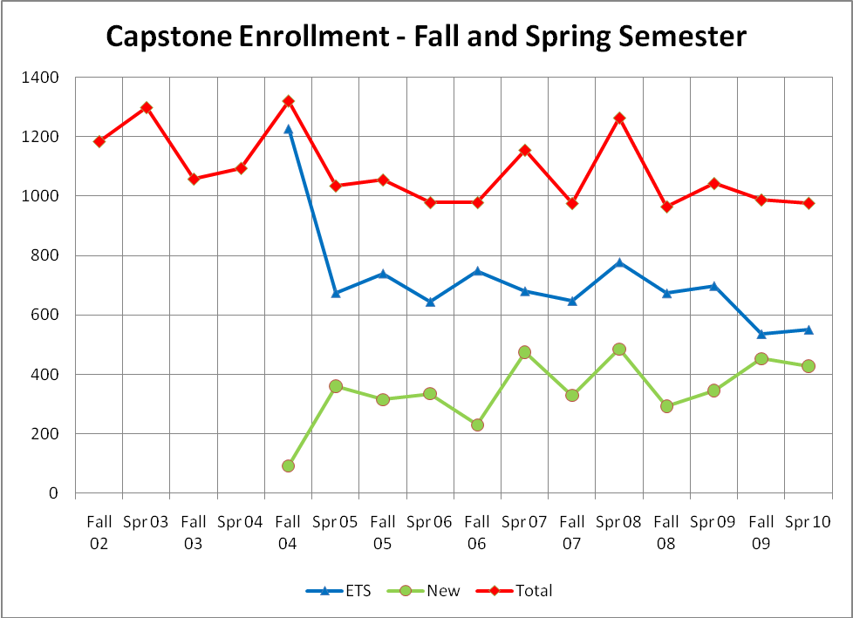
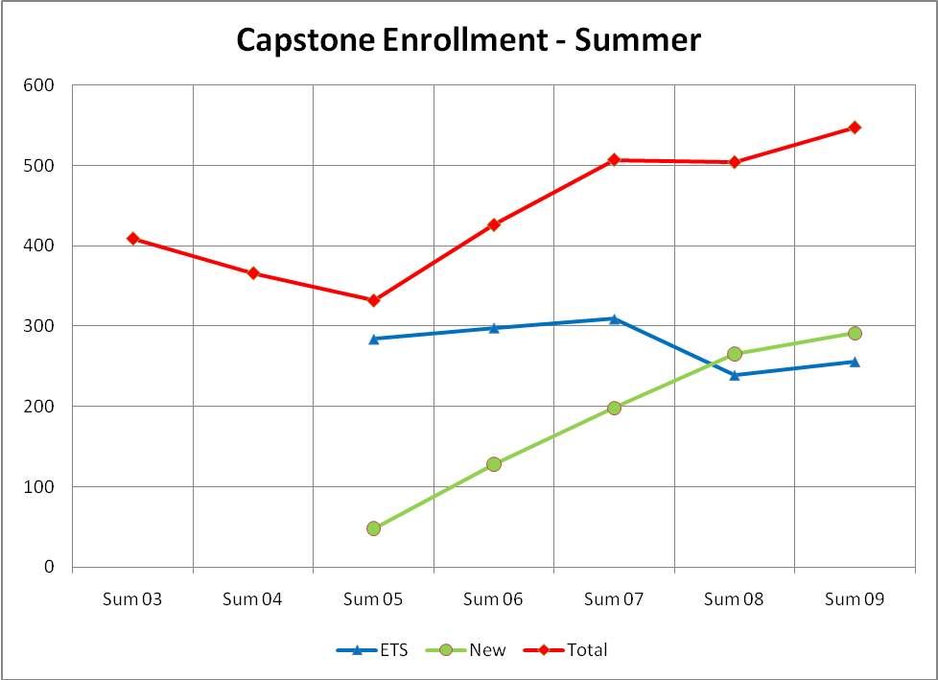
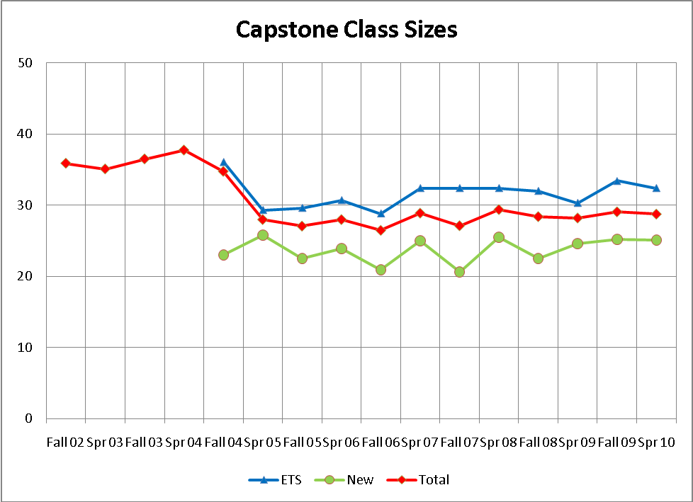

Appendix F – Capstone Staffing and Grades

Columns are: semester, percentage of Environment, Technology and Society (ETS) sections taught by tenured or tenure track faculty, the average GPA for ETS courses, the percentage of the newer Capstone courses staffed by tenured or tenure track faculty, the average GPA of the new Capstone courses, the percentage of all sections taught by tenured or tenure track faculty, and the overall Capstone GPA.

Semester | %ETS Sections  TT | ETS Ave. GPA | %“New” Capstone TT | “New” Ave. GPA | % of all Sections TT | Overall GPA
Fa 02 | 42.4 | 3.47 |  |  | 42.4 | 3.47
Sp 03 | 45.9 | 3.51 |  |  | 45.9 | 3.51
Su 03 | 76.9 | 3.50 |  |  | 76.9 | 3.50
Fa 03 | 72.4 | 3.43 |  |  | 72.4 | 3.43
Sp 04 | 44.8 | 3.52 |  |  | 44.8 | 3.52
Su 04 | 81.8 | 3.49 |  |  | 81.8 | 3.49
Fa 04 | 47.1 | 3.49 | 100 | 2.95 | 52.6 | 3.46
Sp 05 | 47.8 | 3.52 | 100 | 3.23 | 67.6 | 3.42
Su 05 | 84.6 | 3.53 | 100 | 3.38 | 86.7 | 3.51
Fa 05 | 52.0 | 3.48 | 100 | 3.21 | 69.2 | 3.40
Sp 06 | 47.6 | 3.57 | 100 | 3.00 | 68.6 | 3.38
Su 06 | 100 | 3.29 | 100 | 3.47 | 100 | 3.35
Fa 06 | 57.7 | 3.52 | 86.4 | 3.06 | 66.2 | 3.42
Sp 07 | 47.6 | 3.35 | 97.4 | 3.16 | 71.3 | 3.27
Su 07 | 100 | 3.37 | 90 | 3.27 | 96.3 | 3.33
Fa 07 | 55.0 | 3.26 | 96.9 | 3.09 | 73.6 | 3.20
Sp 08 | 54.2 | 3.33 | 97.4 | 3.15 | 73.3 | 3.26
Su 08 | 100 | 3.47 | 92.9 | 3.21 | 96.2 | 3.34
Fa 08 | 52.4 | 3.30 | 88.5 | 3.21 | 66.2 | 3.34
Sp 09 | 69.6 | 3.33 | 96.4 | 3.15 | 79.7 | 3.27
Su 09 | 100 | 3.53 | 83.3 | 3.42 | 89.7 | 3.47
Fa 09 | 43.8 | 3.34 | 97.2 | 3.09 | 72.1 | 3.23
Sp 10 | 29.4 |  | 97.1 |  | 63.2

Graphs on the following pages are of
- Capstone GPA for Fall and Spring Semesters, 2002 – 2009
- Capstone Staffing – percentage of tenured/tenure-track instructors, Fall and Spring Semester, 2002 -2010
- GPA based divided amongst tenured/tenure track and adjuncts, Fall and Spring Semesters, 2002-2009
- Capstone sections offered by each college, 2002-2010

