Senate budget Committee Report for 2015
Prepared by Tim Kidd (chair), Committee: Gerald Smith, Frank Thomas, Hans Isaacson
Purpose: The Senate Budget Committee is tasked with reporting on the state of the UNI budget each year with emphases on spending from the general education fund, spending on instruction related activities, and transfers of money across divisions.
Summary of Overall Budget:
The legislature approved a budget for the regents very late in the year, after the spring term had ended. State appropriations increased to $94.3M for 2015-2016 from $89.2M, however this was accompanied by a loss in one time money from the state of $4M resulting in a net increase of only about $1.1M. The legislature had approved an additional $1.1M in one time funding for UNI, which was vetoed by the governor. In-state tuition was held constant for at least the fall term of 2015, and although freshman enrollment is up by approximately 5%, overall tuition revenue is down about $2.4M. Overall revenues to the general education fund are down by about $1.4M. Personnel expenses (salaries and benefits) increased by $1.6M, although the expenses related to instruction decreased by about $0.3M. Along with other increases in costs, this led to a total of $3.7M which needed to be accounted for in some form of cuts. It should be noted that most the difference between expenses and revenue is being made up in “one-time” measures such as roll-over money, which has become effectively standard practice in the past several years. Additionally, each division (i.e. academic affairs, athletics, etc..) has had to reduce its overall budget in a proportional manner. It should be noted that enrollment numbers appear to be somewhat higher than expected and there is potential for increased tuition for Spring 2016 which will lead to an improvement in the overall budget numbers of approximately $1-1.5M. Overall, the budget will be tight again this year, but the real worry is that continued use of one-time measures to meet budgetary needs is affecting how UNI can make strategic budgetary decisions.

- Overall Budget (General Education Fund) [#’s in $M, rounded to $0.1M]
 | FY15 Budget | Change 15-16 | FY16 Budget | Est. Change 16-17 | Est FY 17 Budget
Revenues
State base | 89.2 | 5.1 | 94 | 5 | 99
State 1 time | 4 | -4
Interest | 0.6 | -0.1 | 0.7 |  | 0.7
Tuition & Fees | 76.9 | -2.4 | 74 |  | 74
Indirect | 1.3 |  | 1.3 |  | 1.3
Sales | 0.5 |  | 0.5 |  | 0.5
Total Revenue | 173 | -1.4 | 171 | 5 | 176
Expenses
Fac & Instr. Off Salaries/Benefits | 75.7 | -0.3 | 75.3 |  | 75.3
Prof. & Sci Salaries/Benefits | 33.3 | 4 | 33.8 | 4 | 37.8
Gen. Service Salaries/Benefits | 25.2 | 1.4 | 26.5 | 1.4 | 27.9
Hourly Wages | 1.7 | 0.1 | 1.8 |  | 1.8
Total Sal/Ben | 135.9 | 1.6 | 137.5 | 5.4 | 142.9
Supp. & Services | 12.2 | -4 | 8.2 |  | 8.2
Library Acq | 2 |  | 2 |  | 2
Rentals | 0.8 |  | 0.8 |  | 0.8
Utilities | 5.8 | 0.4 | 6.2 |  | 6.2
Bldg. Repairs | 1.4 |  | 1.4 |  | 1.4
Auditor Reimb | 0.3 |  | 0.3 |  | 0.3
Equipment | 0.5 |  | 0.5 |  | 0.5
Student Aid | 13.7 | 0.6 | 14.3 |  | 14.3
Total non-sal/ben | 36.7 | -3 | 33.8 |  | 33.8
Total Expenditures | 173 | -1.4 | 171 | 176.4 | 176.4

Notes: FY16 Expenditures estimated at $1.4M less than revenues. Estimated faculty salaries held constant in anticipation of further cuts in the use of adjuncts. Estimated FY17 based on using same changes from 15-16 to 16-17. Does not include final enrollment #’s or potential increase to Spring 2016 tuition. Unclear whether reduced spending on instruction is from reduced adjuncts, full time faculty, or administration although less adjuncts are expected to be utilized this year.

2. Personnel Breakdown
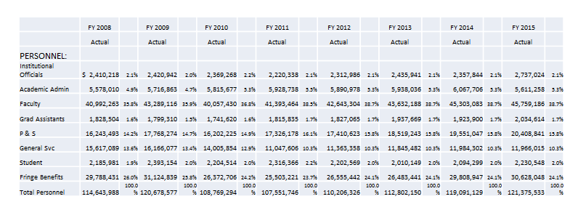
Notes: % of salary spent on faculty relatively constant from 2008-2015. Includes both full time and part time faculty.

3. Special note on auxiliary spending

In the past year the athletics department overspent its budget by approximately $1M, which represents a significant fraction of their overall budget. The university covered this overspending using money outside the general education fund, which the athletics department is expected to pay back including interest at some rate. It should be noted that such over-expenditures do occur from time to time in different divisions, both academic and not. However, $1M represents a larger than usual amount considering the total athletics budget (including all revenue sources) is about $17M. This is in addition to an overall deficit of about $700k that has been accumulating over several years. This deficit has been explained as consisting mainly of an accumulation of vacation days and does not require immediate payment.

4. Budget Transparency
The university passed a policy (2.13: Faculty Participation in University Planning and Budgeting, http://www.uni.edu/policies/213) last spring regarding faculty participation in the university budgeting process. As part of this process, faculty are to take part at the department level in establishing budget priorities, college senates will participate at the college level, and at the university level the process will involve the faculty senate. We are currently working out the means by which information is to be conveyed to faculty. Ideally, this information will be easily understandable, contain a three year reporting period, and be easily obtainable using existing reporting methods. The form of these reports will be determined this fall, and may be optimized in the coming years. It is recommended that, on an annual basis, faculty take part in budgetary discussions by having each department head disperse such reports and ask for input during a department meeting, the college senates do so in the same manner with the dean, and the senate budget committee receive university and college level reports for compilation and distribution to the senate. Additionally, it is recommended that the senate consult on at least an annual basis with a representative from the finance office, especially near the end of the Spring term to discuss budget issues for the coming year.

