The Iowa Public Employment Relations Act became law in 1974. This law has given public sector employees in Iowa the right to collective bargaining for over forty years. Based on the National Labor Relations Act passed by Congress in 1935, this law empowers public sector employees, including UNI faculty, to negotiate with their employers in an equitable manner. The right to collective bargaining freed American workers from the unsafe working conditions, job instability, and long hours common to the 19th century and provided the environment which gave birth to the middle class, the backbone of the U.S. economy. At UNI, United Faculty has been instrumental in maintaining a healthy relationship with the university administration and providing the working conditions that enable faculty to focus solely on the true mission of the university: enabling students to reach their full potential and succeed in the competitive world that awaits them after graduation.
It is no coincidence that as membership in collective bargaining units throughout the United States has declined, so have the fortunes of most Americans. Iowa is no exception to the rule, facing the same issues of income inequality and reduced opportunity as the rest of the country. For Iowa to prosper, the state should support the right and freedom of all Iowans, in both the private and public sector, to choose whether to engage in collective bargaining or not. Actions to eliminate or reduce the rights of workers enshrined in chapter 20 of the Iowa state code would be detrimental for all Iowans working in the public sector who work in service of the public good. Therefore, as representatives of the faculty of the University of Northern Iowa, we support the freedoms and rights protected for over forty years by chapter 20 of the Iowa code and oppose any actions that would infringe upon them.

Chair of the Faculty
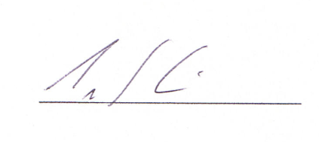
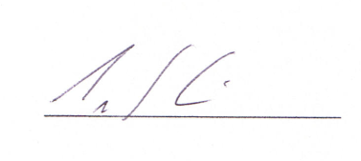
Tim Kidd

Faculty Senate

